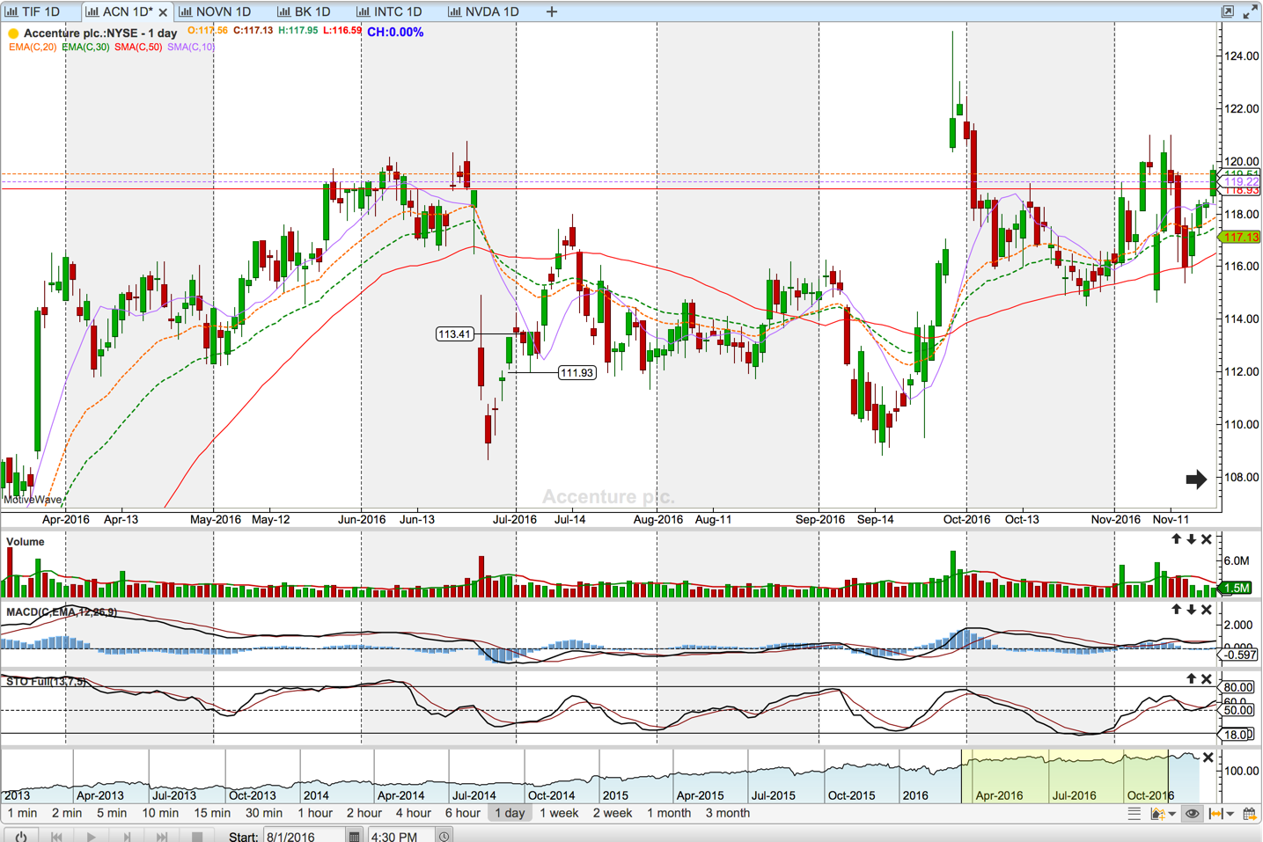

Bought on July 5th, Aug 19 110 put when the ACN price was around 113.4 for 2x1.80 =$360. That was all lost as the entry was horrible. There was a rising window on June 30th as a result the price retreated into 111.9, it bounced and went into 118 level before it started to retreat.